**IOT BASED ANTI THEFT DETECTION AND ALERTING SYSTEM USING RASPBERRY PI**

**Abstract -** To secure and guard our house in our absence, we propose the IOT based Anti-theft detection and alert System using Raspberry Pi. One single step anywhere inside the room Is tracked and user is alarmed through mms and phone call over IOT..

***Key Words*: IOT (Internet of Things), Raspberry Pi, Call, Message, Pi Camera.**

**1. INTRODUCTION**

Now-a-days, Security has become the most challenging task. Everyone wants safety but in present scenario, nothing is safe not even in their own houses. Home is a place where we keep our assets and our capital. But we can never be sure about the security of that asset behind us and the possibilities of intrusion are increasing day by day. We generally lock houses when going out of the house. But just locking the home is not enough, there must be a system which safety our home, belongings and income from theft is the necessary requirements for home security system and keep track of the activities and report to the owner accordingly and works according to the response of the owner.

**1.1 Proposed System**

**Anti-Theft Detection And Alert System Using Raspberry :**

Whenever the thief enters in the house, we use open cv library with python to detect thief’s entry and when thief is detected it sends a valid signal to the raspberry pi which turn alerts the owner through mms, phone call.

**2. SYSTEM BLOCK DIAGRAM**

**Fig. 1** Block diagram of Raspberry-pi based anti-theft detection system

Raspberry – pi zero

WH

Camera

**2. Literature Survey**

Below are several of the best Products considered as security measure as Anti Theft Device

• Gear Locks : Considered one of the best protection, a car thief would in a very rare circumstance puts up time to break gear lock in the car - which may use energy and time, rather is always on viewpoint of models which are parked without gear lock in it.

• Ignition Cut Off : A key-operated or hidden manual switch that interrupts the power supply from the battery to the ignition. This monitor switch can be taken out by the driver once the car is locked. • Car Alarms : There are several alarm systems that will support to deter or depress vehicle thefts, and alert others of enforced entry into the car. You must need to make certain that these noise speakers should be installed in such a way as not to be easily able to reached on glance, else will be first disabled by them.

• Steering Lock : A long metal bar with a lock that fits on the steering wheel and is intended to prevent the steering wheel from turning. Steering wheel locks are effective when using in combination with Gear Lock.

• ICAT : ICAT means Intelligent Computerized Anti-Theft system. Though, most of the models come with I-cat feature, still for those which don’t have, under this system, The car starts only when the sensor in the vehicle receives the chip in the key (wherein that secret code is matched of the key with the chip). Even, sensors creates alarms buzz when somebody try to insert a fake key in a car .

• Gps Tracker : A GPS facility can help tracking a stolen car. Infact, can also alert you for misuse of your car by any Service Station.

**2.1 Existing Systems**

Several anti-theft control systems have developed over the previous few years. An integrated Info-Security Circuit Board that communicates with ECUs and sensors inside a vehicle through LIN bus,CAN bus, Flex Ray and MOST Bus communicates with other vehicles, road-side structures and mobile phones with wireless interfaces. The main disadvantage with the system is the data timeliness and network delays to understand reliable safe car communications. The existing car antitheft system are flashing light techniques, Car alarm which makes use of different type of sensors which can be pressure, door & tilt and shock sensors.

Other systems include an in vehicle anti-theft component that will not enable the functions of the applications if it should find itself is illegally moved to one more car. The restriction here is that it needs a secure processor and smart card chips to store in the Group Identification Number. There are numerous remote controlled security systems that restricts key auto systems of automobile through remote control when it is stolen. This needs secure vehicle-vehicle communications.

Apart from above devices there are different methodology to implement security in the system Such as

• Single level Security

• Multilevel Security



**2.2 Advantages and Disadvantages Of The Existing System**

In 1997 B Webb present wheel and steering lock system, to prevent car from theft, but they are visible from outside the car and prevent the wheel from being turned more than a few degrees. The next system was projected on Security Module for Car Appliances by Pang-Chieh Wang,et.al. This system prevents car appliances from stealing and unlawful use on other cars. If illegal moving and use a car appliance with the

security module without approval occur that will lead the appliance to useless. But it does not prevent vehicle from theft. In 2008 Lili Wan, et.al. implemented new system based on GSM in which owner can obtain the alarm message rapidly and if necessary, also it can monitor the car by phone .The subsequent system was a sensor network created vehicle anti theft System (SVATS). In this method, first step is to form a

sensor network by using the sensors in the vehicles that are parked within the same parking area, then identify and monitor possible vehicle thefts by detecting illegal vehicle movement. An alert will be reported to a base station in the parking area if an illegal movement is detected. As the sensor cannot link

with the base station directly in the extreme case, automobile cannot receive any safety when no neighbors can be found even if a sensor has tried its extreme power level. In authors describe an automotive security system to disable an key auto systems of automobile through remote control

when it is stolen. But it does not help to identify the theft.

An effective automotive safety system is implemented for anti-theft by an embedded system occupied

with a Global Positioning System (GPS) and a Global System of mobile (GSM) by Montaser N. Ramadan et.al. to monitor and track vehicles that are used via certain party for particular purposes, likewise to stop the automobile if stolen and to track it online for recovery. The subsequent system was projected in 2013 on real time automobile theft identity and control system created on ARM 9. It achieves the real time user verification using face recognition, using the Principle Component Analysis (PCA) algorithm if the outcome is not accurate then ARM produces the signal to block the car access and the car owner will informed about the illegal access with the help Multimedia Message Services (MMS) via GSM modem . But in this technique the camera captures owner’s image only. If the owner’s friends or relatives want to start the car it will not start . Newly innovative system proposed on vehicle anti-theft system based on an embedded platform comprises of multiple layers of security .The first layer of security in the system is a fingerprint recognition, created on which the doors are opened. Also to avoid thieves from breaking the glass and getting inside the vehicle, vibration sensors are used in all the windows with a threshold level to avoid wrong alarms. the vehicle is turned on only with the mechanical keys along with correct key number entry on the combination keypad present, failing to do so for three successive times will result in vehicle getting stopped by

cutting the fuel supply and an alert message is lead to the mobile number of the owner. Additional to prevent the capture of the vehicle, tyre pressure sensor is also being used which also alerts the owner via a mobile message.

In circumstances of vehicle accident detection new system projected by Varsha Goud et.al. on vehicle accident automatic detection and remote alarm device. This system can sense accidents in significantly less time and sends the basic info to first aid center within short time covering geographical coordinates, the time and angle in which a vehicle accident had happened. This attentive message is sent to the rescue team in a short time, which will benefit in saving the valuable lives . Spotting an accident previously occurring it can save human life. To implement this new system was projected in which a car will try to avoid hurdle after avoiding animal or human if there is any. Driver will also be informed with red lights specifying that obstacles are in front. But, if the system would not be incapable to avoid accident then this system will habitually generate a tweet in tweeter. For further safety, this system also comprises buzzer and relay where relay helps to protect the car from battery ignition and buzzer will make noise to notify people surrounded.

In 2000 paper recommended on An Introduction to Face Recognition Technology which covers topics such as the generic framework for face recognition, several state of the art face recognition algorithms and factors that may affect the performance of the recognizer. New system has been proposed in 2004 thru Jian Yang, et.al. is two-dimensional principal component analysis (2DPCA) aimed at image representation. As contrasting to PCA, 2DPCA is based on 2D image matrices rather than 1D vector so there is no necessity to change image matrix into a vector prior to feature extraction. Because of this an image covariance matrix is constructed openly by means of the original image matrices and its eigenvectors are resulting for image feature extraction . The succeeding paper projected on image-based face detection and recognition to assess various face detection and recognition methods, which offer complete solution for image based face recognition and detection with higher accuracy, better response rate as an early

step for video surveillance.

**3. HARDWARE DESCRIPTION**

**1. Raspberry Pi**

The Raspberry Pi Zero W is size of only 65mm long by 30mm wide, with the addition of wireless LAN and Bluetooth. The Pi Zero W is designed to be as flexible and compact as possible with mini connectors and an unpopulated 40-pin GPIO. At the heart of the Raspberry Pi Zero W is a 1GHz BCM2835 single-core processor with 512MB RAM.

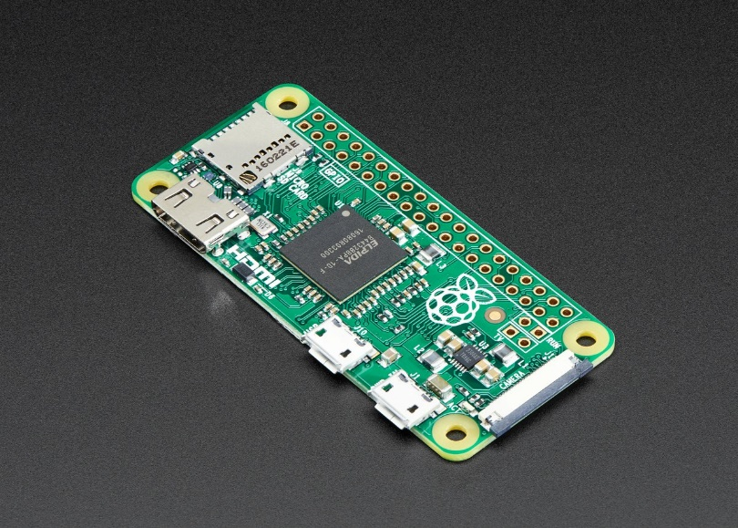

**2. Raspberry Pi Camera**

Camera module is Pi camera interfacing to the raspberry pi module. Its resolution is 5-megapixel and still picture resolution 2592 x 1944, Max image transfer rate 1080p: 30fps, this Pi camera module is used for captures an image and send captured image to the Raspberry pi modul

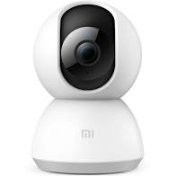

**4. SOFTWARE DESCRIPTION**

The software components are used for the project has been mentioned below:

**4.1 Raspbian OS:**

Raspbian is an unofficial port of Debian Wheezy armhf with compilation settings adjusted to produce optimized "hard float" code that will run on the Raspberry Pi. This provides significantly faster performance for applications that make heavy use of floating point arithmetic operations. All other applications will also gain some performance through the use of advanced instructions of the ARMv6 CPU in Raspberry Pi. Although Raspbian is primarily the efforts of Mike Thompson (mpthompson) and Peter Green (plug wash), it has also benefited greatly from the enthusiastic support of Raspberry Pi community members who wish to get the maximum performance from their device.

**4.2 PYTHON:**

Python is an easy to learn, powerful programming language. It has efficient high-level data structures and a simple but effective approach to object-oriented programming. Python’s elegant syntax and dynamic typing, together with its interpreted nature, make it an ideal language for scripting and rapid application development in many areas on most platforms. The Python interpreter and the extensive standard library are freely available in source or binary form for all major platforms from the Python Web site, https://www.python.org/, and may be freely distributed. The same site also contains distributions of and pointers to many free third party Python modules, programs and tools, and additional documentation. The Python interpreter is easily extended with new functions and data types implemented in C or C++ (or other languages callable from C). Python is also suitable as an extension language for customizable applications.

**4.3 OPEN CV:**



Open CV (Open Source Computer Vision Library) is an open source computer vision and machine learning software library. Open CV was built to provide a common infrastructure for computer vision applications and to accelerate the use of machine perception in the commercial products. Being a BSD licensed product, Open CV makes it easy for businesses to utilize and modify the code. It is free for both commercial and non-commercial use.

**4.4 Firebase**



**Firebase** is a Backend-as-a-Service (Baas). It provides developers with a variety of tools and services to help them develop quality apps, grow their user **base**, and earn profit. It is built on Google's infrastructure. **Firebase** is categorized as a NoSQL database program, which stores data in JSON-like documents.

**4.5 Twilio**



**Twilio** is an American cloud communications platform as a service (CPaaS) company based in San Francisco, California. **Twilio** allows software developers to programmatically make and receive phone calls, send and receive text messages, and perform other communication functions using its web service APIs

**4.6 YOLO**

**YOLO**, a single CNN simultaneously predicts multiple bounding boxes and class probabilities for those boxes. **YOLO** trains on full images and directly optimizes detection performance. This model has a number of benefits over other object detection methods: **YOLO** is extremely fast.

**5. ARCHITECTURAL FLOW OF SYSTEM**

Following Figures shows the architectural flow of system installation process and working of the proposed system which will lead to prevention of Theft.

start

On camera with program

Checking for movement in each frame

Movement detected

NO

YES

Take image and send to cloud message and call the owner

Checking for movement in each 100th frame

Movement detected

NO

YES

Take image and send to cloud, message the owner

**6. WORKING AND RESULT**

In this project raspberry Pi zero (model) has been used as heart of system. This proposed system is an intelligent system and it eliminates the need of continuous by human resource. Thus, any human extra work is ruled out. This system continuously checks the status of place by sensors that is anyone entering in the home or not. And sends the alert message to the owner with live images by using camera with different angles. The main aim of this project is to make an automated security system for Home, Banks or jewelry shops. The project consists of Raspberry Pi with sensor and camera. The whole system is placed in that place. If system detect someone in Home/Bank/shop it sets the capture the live images and sent it on phone through mms.

**7. ADVANTAGES**

1. The device was capable in distinguishing between human and object using AI.

2. It was using an alarm system which uses to alert the owner by making phone call, mms.

3. It was convenient in use, relatively free from false alarms and does not require frequent user action to arm and disarm the system.

**8. DIS-ADVANTAGES**

1. The sound was made by device will not be recognized by the owner, if he/she is not present there.

**9. APPLICATIONS**

➢ Jewellery Shops

➢ Army Surveillance

➢ Bank Locker Room

➢ Museum Security

➢ Home Security

**10. CONCLUSIONS**

The research work that will be carried out in this thesis would be mainly focused to design and develop efficient and convenient motion detection surveillance i.e. an Anti-Theft device to solve security problems which will help to reduce/stop theft. This system is suitable for small personal area surveillance. I.e. personal office cabin, bank locker room, parking entrance. Whenever the motion is detected through. The main Advantage of the project is Easy to implement, Low cost with High quality.

**REFERENCES**

answers.opencv.org, stackoverflow.com, Stackexchange.com

**BIOGRAPHIES**

**A.AKASH(180701017)**

A UG Third Year student seeking his degree in Computer Science Engineering at Rajalakshmi Engineering College, Thandalam, Chennai.

**V.AKASH(180701018)**

A UG Third Year student seeking his degree in Computer Science Engineering at Rajalakshmi Engineering College, Thandalam, Chennai

**M.ARUN KUMAR(180701035)**

A UG Third Year student seeking his degree in Computer Science Engineering at Rajalakshmi Engineering College, Thandalam, Chennai

**V. BALAJI(180701047)**

A UG Third Year student seeking his degree in Computer Science Engineering at Rajalakshmi Engineering College, Thandalam, Chennai

**B. CHRIS GAVIN(180701056)**

A UG Third Year student seeking his degree in Computer Science Engineering at Rajalakshmi Engineering College, Thandalam, Chennai